Evidence for Project Unit

Kynan Song

Cohort E16

Date:

P – 1 Github Contributors page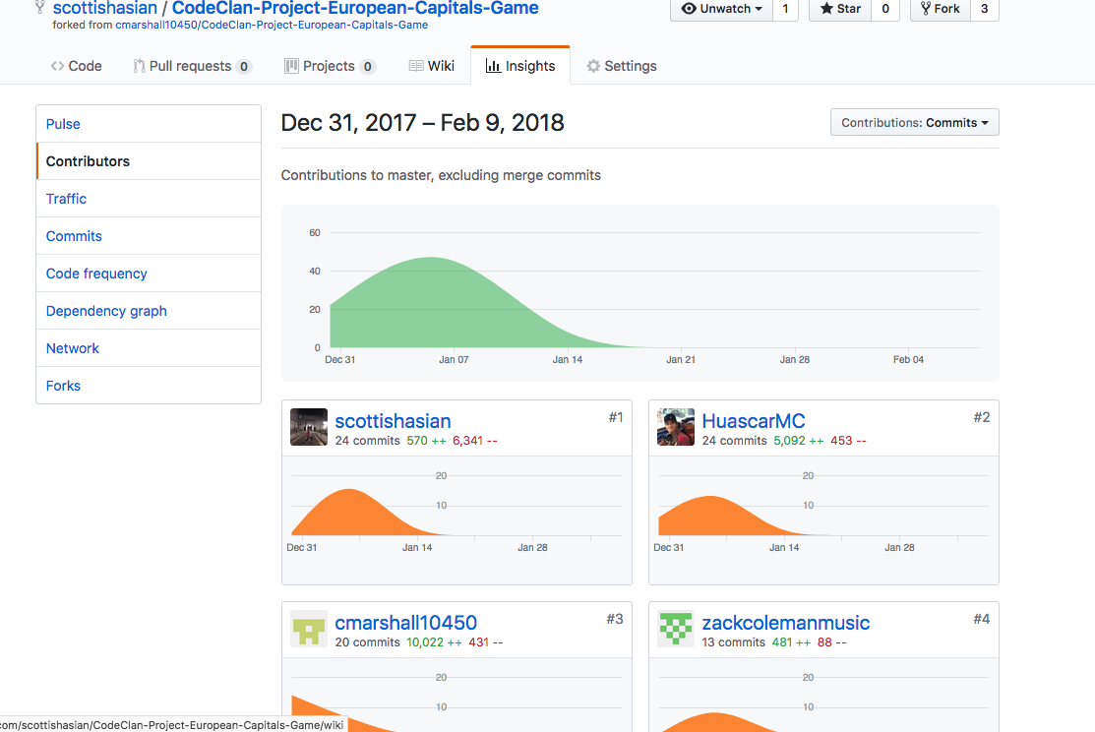

P – 2 Project Brief

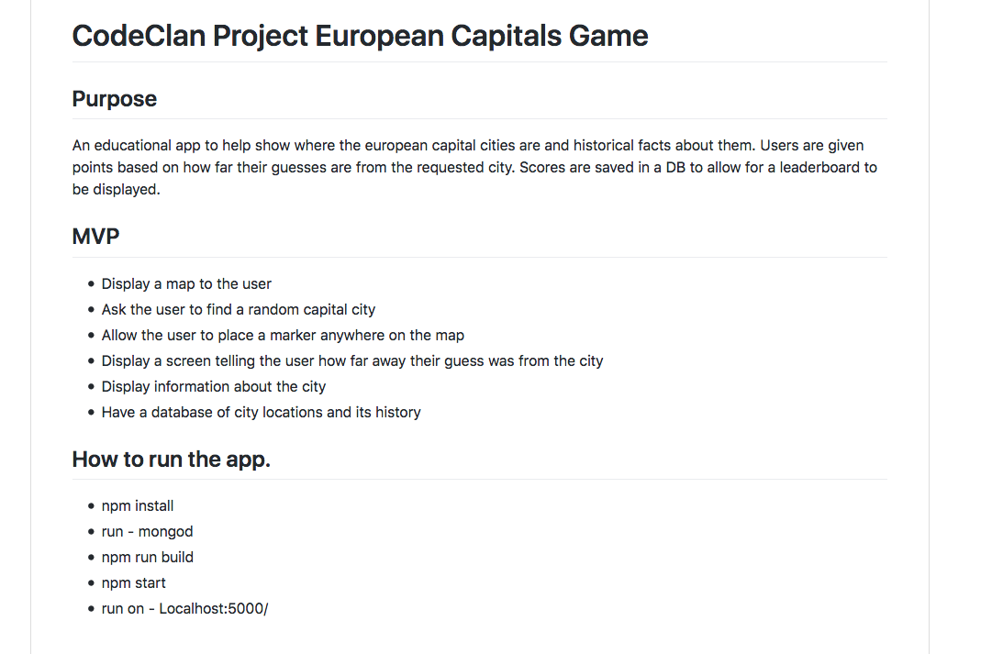

P – 3 Use of Waffle.IO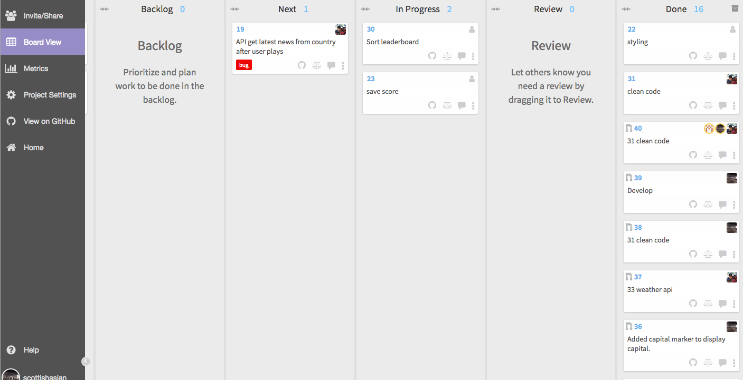

P – 4 Acceptance Criteria

P – 5 User Site-Map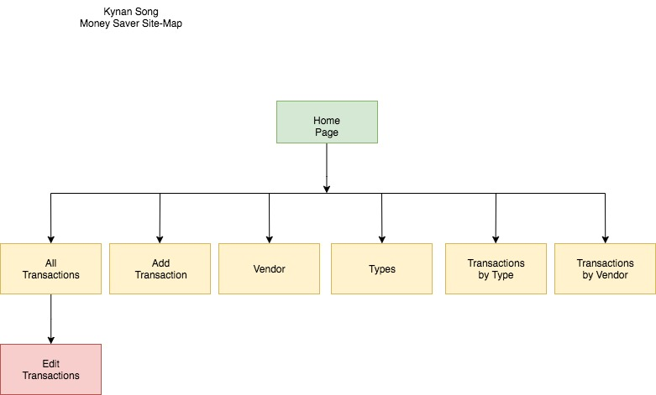

P -6 Wireframes

MoneySaver Project

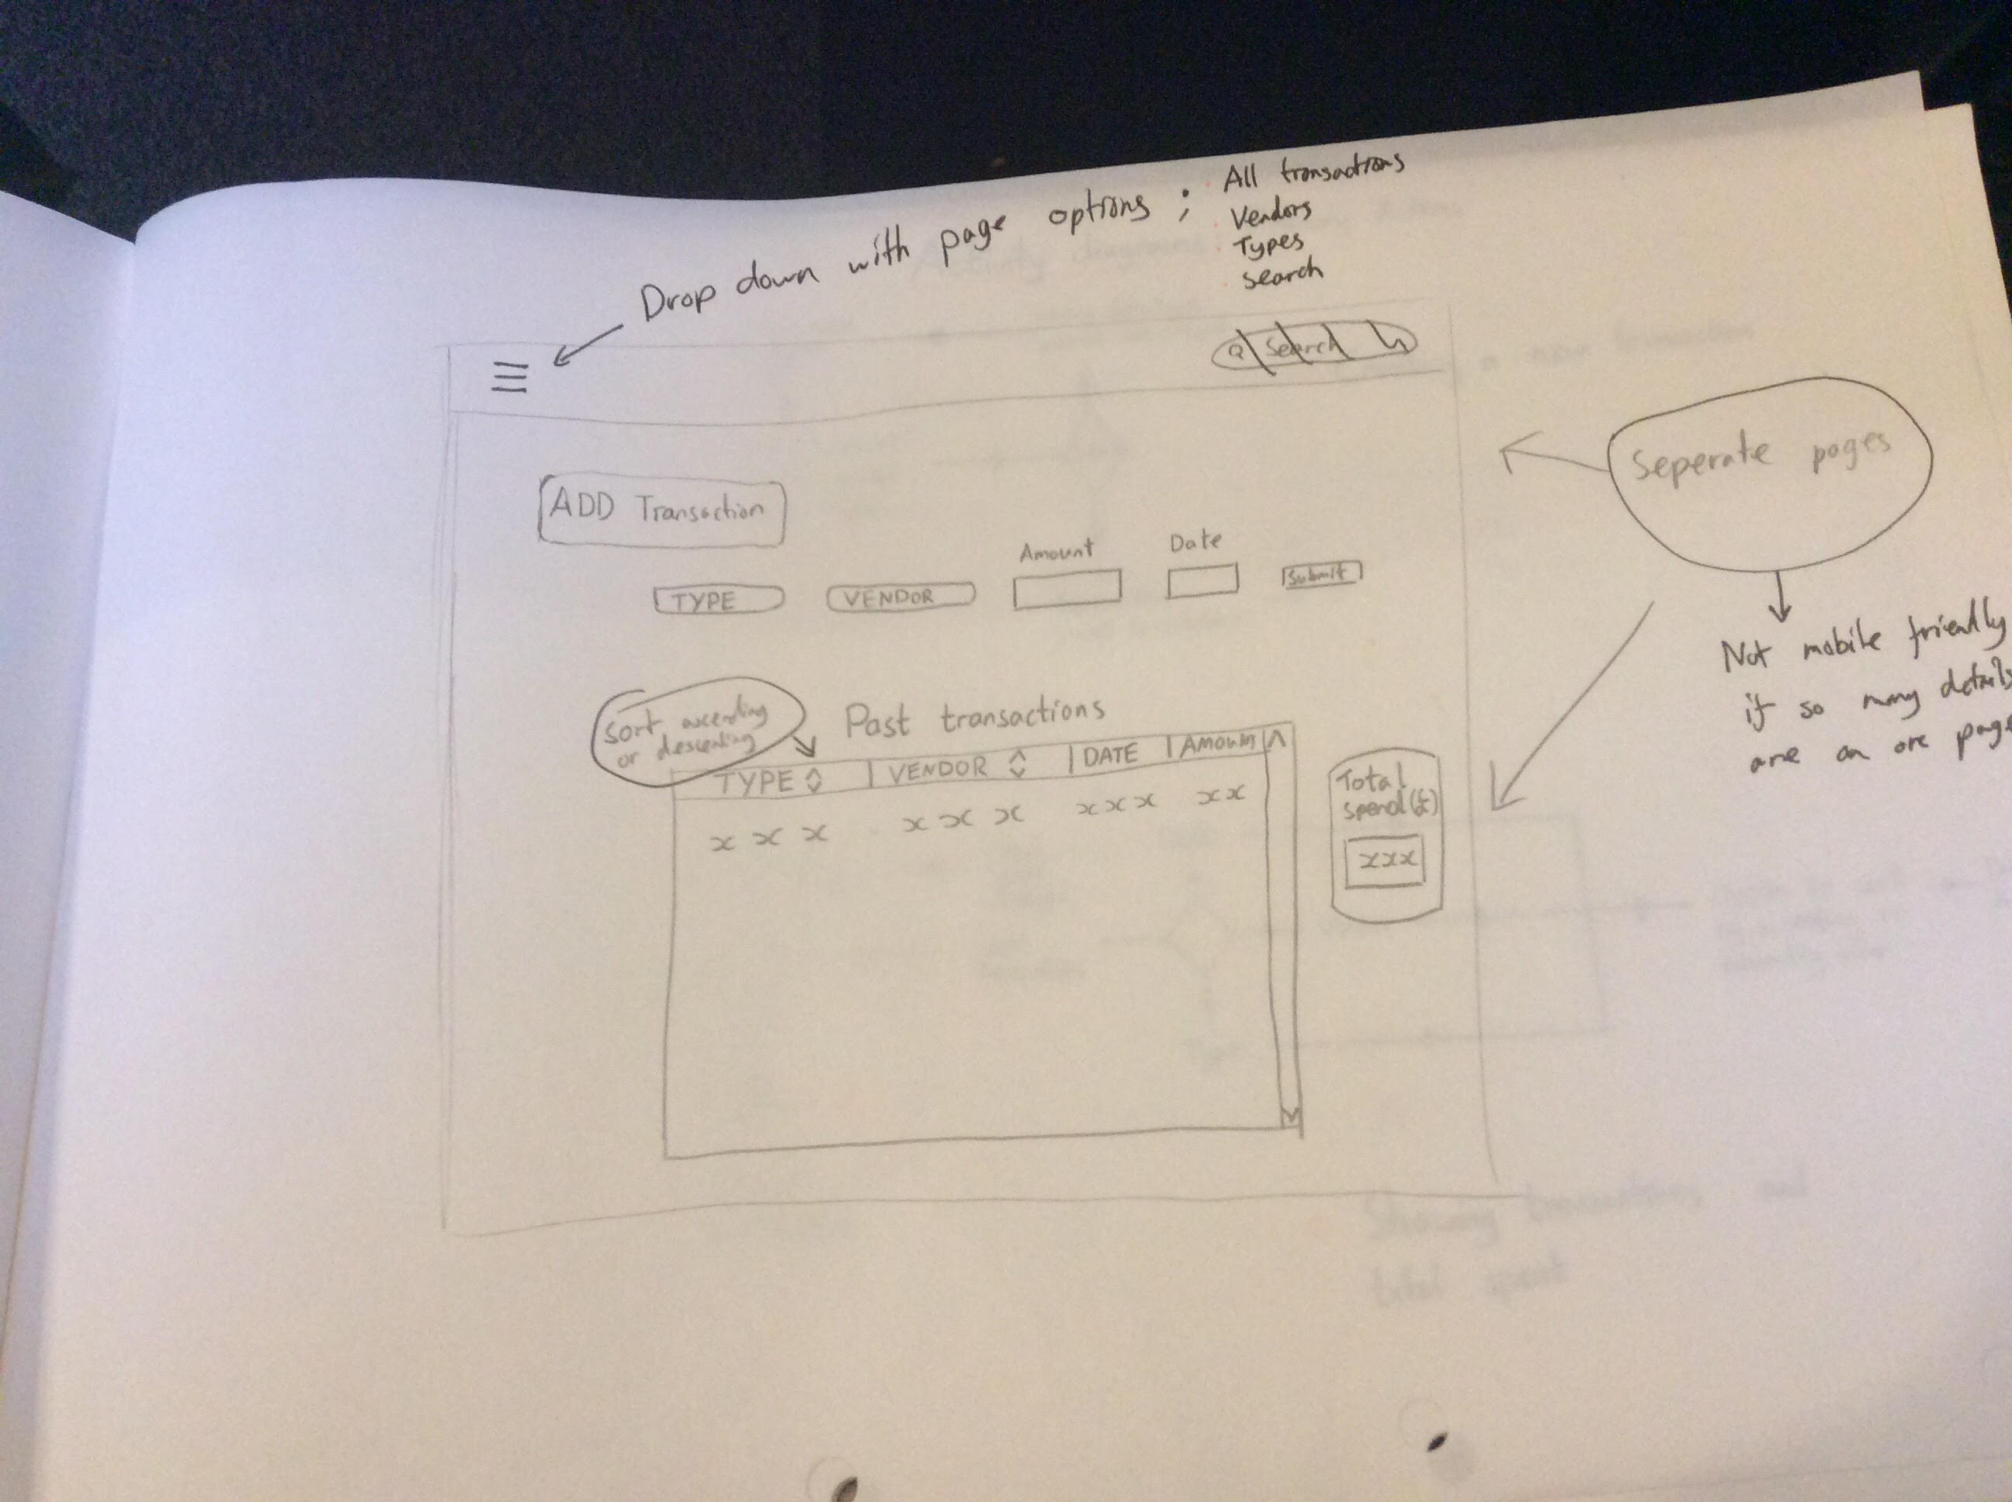

Geography with Friends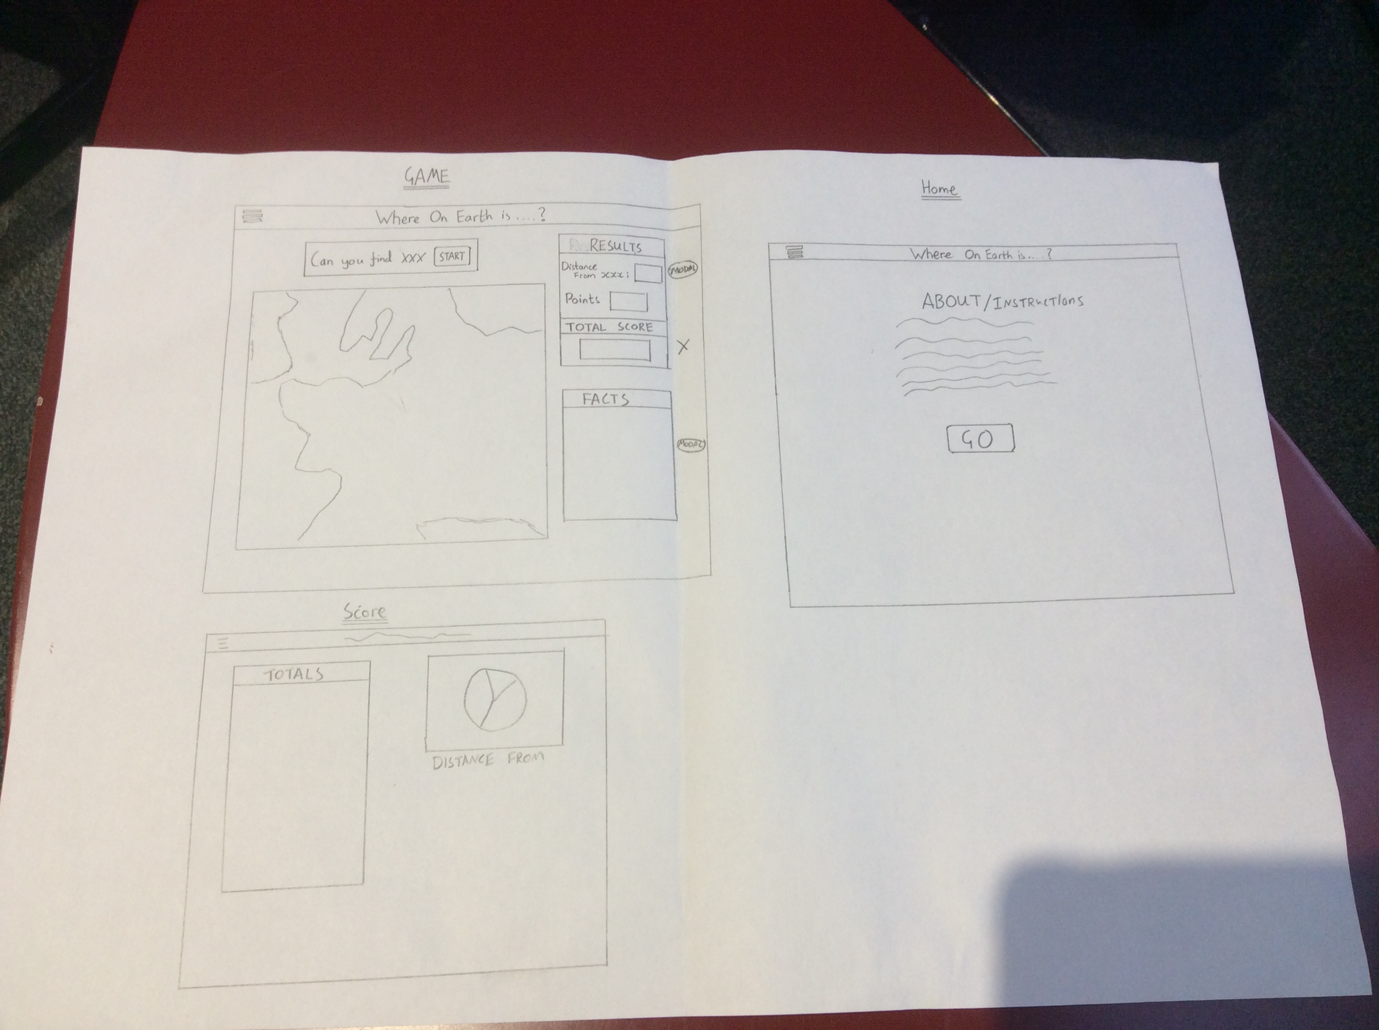

P – 7 Systems Interaction Diagrams

P – 8 Object Diagrams

P – 9 Algorithms

P – 10 Pseudocode

P – 11 Github Link

[https://github.com/scottishasian/Drinkable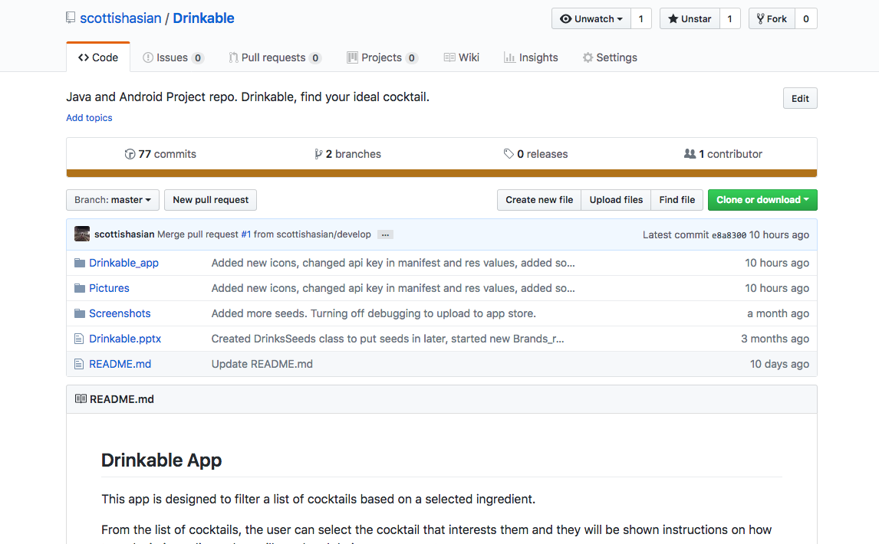](https://github.com/scottishasian/Drinkable#)

P - 12 Stages of Development

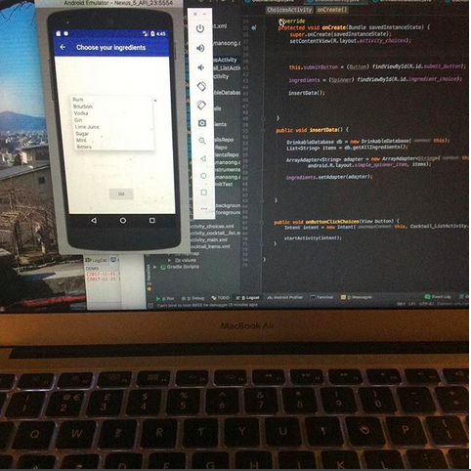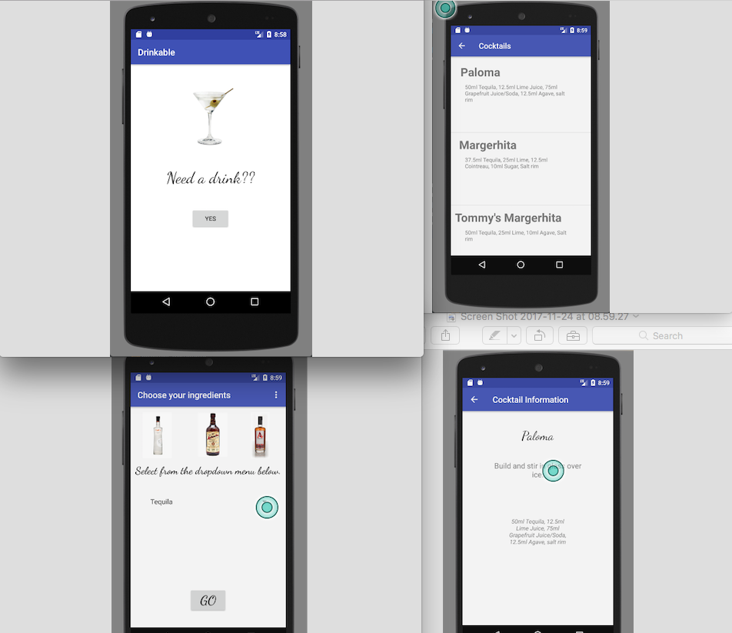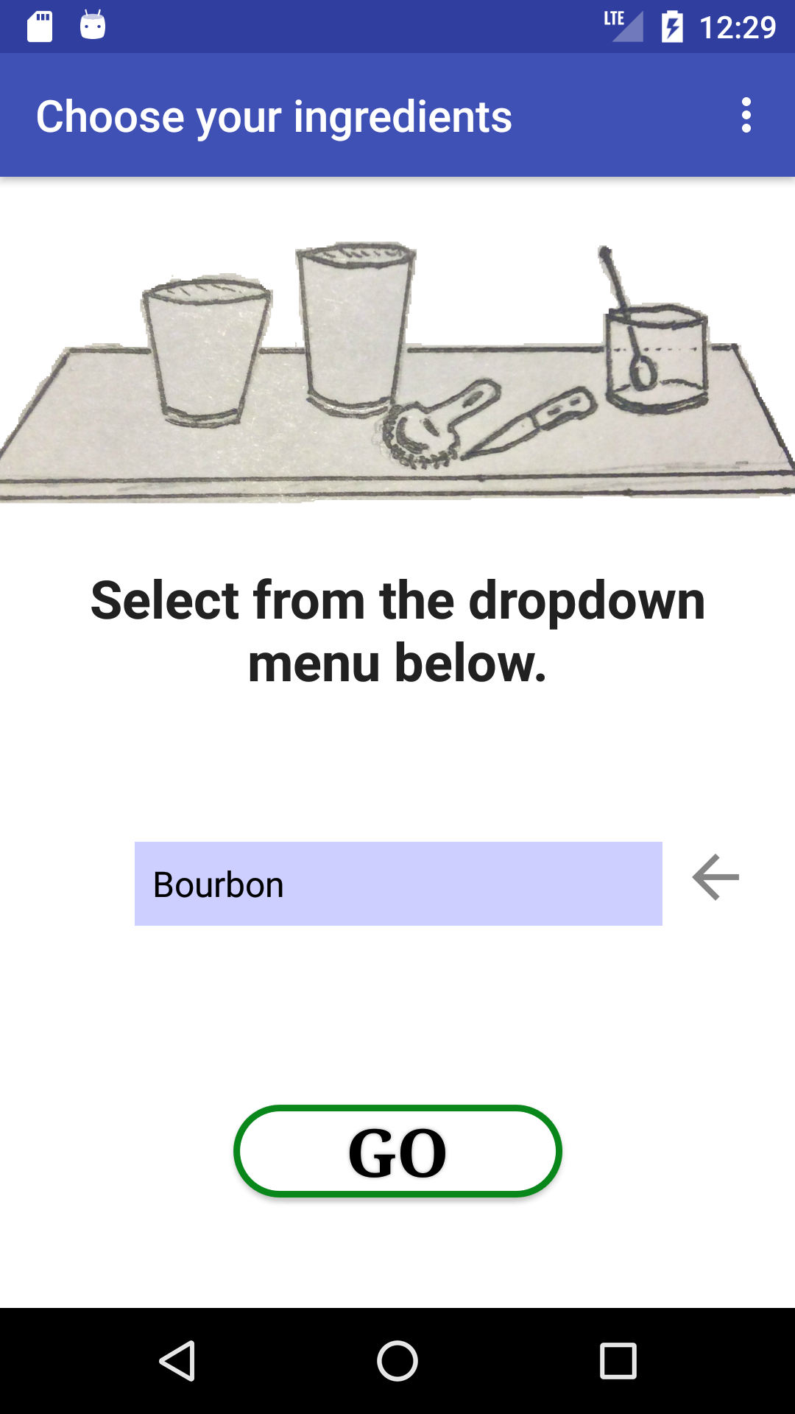

P – 13 User Input

P – 14 Data Persistence

P – 15 User Output

P – 16 Use of an API

P – 17 Bug Tracking Error Report

P – 18 Testing